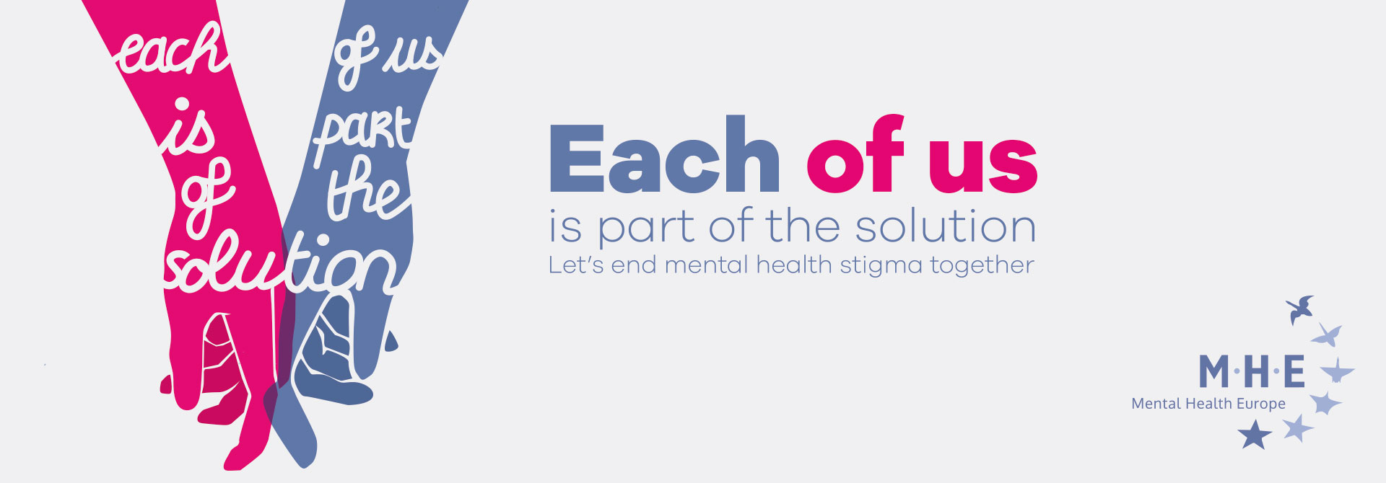
Want to help us and translate the campaign’s main content?
You will find the main content to translate below! Please just return the translate document to our secretariat, and we will take care of the rest. Thank you so much for you support!
CAMPAIGN DESCRIPTION:
What is Each of Us?
Each of us is an anti-stigma and discrimination campaign run by Mental Health Europe. The main objective of this campaign is to raise awareness of mental health issues. Each of Us seeks to show that mental health problems are more common than we think, and that each of us can be part of the solution in changing mentalities and ending stigma and discrimination against people with mental health problems.
- One in four of us can expect to experience a mental health problem during our lifetimes.
- One in five adolescents in Europe is affected by at least one psychological problem in any given year.
- Three-quarters of European businesses report the presence of at least one psychosocial risk in the workplace.
The figures speak for themselves: mental health is a major public health, economic and social issue that concerns millions of Europeans today throughout the life span.
Why an anti-stigma campaign?
Although awareness around mental health issues have improved over the last decade, the stigma and discrimination people with mental health problems face remain unacceptably high. This is mainly due to social perceptions of mental health problems which are mainly dominated by negative stereotypes. Misconceptions about people with mental health problems continue to prevail not only in the media but also on TV, within professional and school setting as well as in the health sector mainly due of lack of knowledge and awareness.
Running anti-stigma campaign at local, regional and national level by targeting specific groups help raising awareness and combating misconceptions and stereotypes. We need to put an end to stigma and discrimination because people with mental health problems are being discriminated against in daily life, being denied access to goods and services or being treated unfairly, but also because stigma can reduce the willingness of policy makers to invest in mental health.
Who is this for?
This campaign targets policy makers, young people, employees and the general public to raise awareness and end stigma around mental health.
CAMPAIGN Leaflet 1
10 Myths about Mental Health that you can help us debunk!
- Mental health problems are rare
I’ll never be affected. Mental health problems are actually very common. 1 in 4 people will experience a mental health problem in any given year.
- Mental Health: it’s all in the head.
Mental health problems are often caused by external difficulties such as life events like divorce or bereavement, or by wider socio-economic factors like poverty or homelessness. They can also cause great distress, and can affect every part of your life, including your physical health, your relationships and your work. There’s definitely more to it than just your head!
- Only weak people have mental health problems.
Experiencing a mental health problem is NOT a sign of weakness and it is not something to be ashamed of. Mental health problems can often be human ways of coping with and making sense of complex life experiences such as grief or trauma.
- People with mental health problems are dangerous and violent.
It’s the other way around. People with mental health problems are unfortunately more likely
to be victims of violence or harm.
- Medication is the only solution!
While medication can help some people experiencing mental health problems, it should be seen as part of the solution rather than the sole solution: progressive alternatives exist, and we should promote them.
- People with mental health problems cannot work.
Meaningful work in a supportive environment can be a very important part of recovery. It is
also very likely that we all work with someone experiencing a mental health problem, but we may not know about it because of the fear of stigma and discrimination.
7. Young people and adolescents are going through turbulent times, nothing to worry about, it’s puberty!
Globally, 1 in 5 adolescents will experience some kind of mental health problem in any given year. Adolescence is a challenging transition period when mental health problems are most likely to develop
8.Physical and mental health are completely separate things
Physical and mental health are highly intertwined and should not be treated separately as they both impact on each other.
9. People with mental health problems should stay in hospital.
There are many progressive alternatives to traditional psychiatric hospitals which have proven to effectively help people with mental health problems, such as community service or peer support.
10. People do not recover from mental health problems.
With the right kind of help, people can and do recover from mental health problems. Recovery is not the eradication of the experiences or symptom. It means living with and managing these experiences, whilst having control over and input into your own life.

CAMPAIGN Leaflet 2
Want to help us ending stigma around mental health?
Here is what you can do!

Take a picture of you and/or your team with your Each of Us badge or the campaign leaflet

Share it on social media with the following hashtag:
#eachofus

You can also share your own story on the campaign’s website
eachofus.eu

Speak up! Share our “10 Myths” leaflet among your friends, family and colleagues!

Visit our website eachofus.eu to find out more on how we can help end mental health stigma together

